TakingITGLobal
Global Youth Coalition on HIV/AIDS (GYCA)
and
The Centre for Global Education
Present

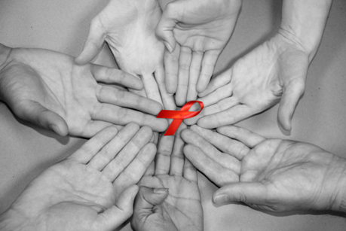

The World AIDS Days Video Conference

Date: Dec 1st, 2010
Time: 9:00-11:00 (MDT, GMT-7)

Acknowledgement

Teacher resources have been prepared by TakingITGlobal. For more information, please visit, http://www.tigweb.org/tiged/

Participants/
Research Institutions

The Centre for Global Education
Location: Edmonton, Alberta, Canada
Direct Cell: 780-700-4482

TakingITGlobal
Location: Toronto, Ontario, Canada

GYCA
Location: New York, New York, USA

Queen Elizabeth High School
Location: Edmonton, Alberta
Teacher: Brenda Scaddan and Chad Bartsch

Colonel By Secondary
Location: Ottawa, Ontario
Teacher: Cameron Baird

Thomas Jefferson Instituto
Location: Mexico City, Mexico
Teacher: Monica, Masahiro

Secondary Medical School Ante Kuzmanica
Location: Zadar Croatia
Teacher: Edin Kadic

Winston Churchill High School
Location: Lloydminster, Alberta
Teacher: Crystal Scutt

Del Valle High School
Location: Del Valle, Texas
Teacher: Michael Cunningham

Horvati School
Location: Zagreb, Croatia
Teacher: Suzana Delic

NATIONAL NILUFER ANATOLIAN HIGH SCHOOL
Location: Bursa,Turkey
Teacher: Aylin Esmen

Netagamiou School
Location: Netagamiou, Quebec
Teacher: Ana Osborne

Tallwood High School and
Global Studies and World Languages Academy
Location: Virginia Beach, Virginia
Teacher: Gayle Hartigan
World AIDS Day
December 1st Agenda:
Main Room IP: (2020@...)

(There will be a Blog/Discussion Forum set up during the VC for students to offer feedback on an ongoing basis throughout the VC. There will be a team of researchers monitoring this forum and offering feedback. Visit http://avc.tiged.org/aids2010)

9:00 – 9:05 Welcome, Introductions (2020@... )

9:05 –9:25 Expert Issue Orientation (2020@...)

9:25 – 9: 45 – Breakout #1 (One school is partnered with the mentors)
Room #1: TBA 2020@...
Room# 2: TBA 3303@...
Room# 3: TBA 3303@...

Activity session #1: The State of HIV/AIDS –
What is HIV/AIDS? What does someone with HIV/AIDS look like? What is the present situation in your community and around the world?
- Students share pictures, recent news articles, information on local AIDS/HIV issues
- Students will share and compare their recommendations on domestic policy
- Student will try to reach a consensus on the recommendations they will put forth

9:45 – 9:50 Mentor Summary (2020@...)

9:50 – 10:10 Breakout #2
Room #1: TBA 2020@...
Room# 2: TBA 3303@...
Room# 3: TBA 3303@...

Activity session #2: The Developed and Developing
- Do Developed countries have a responsibility to the Developing world in the plight with HIV/AIDS? What should this look like?

10:10 – 10:15 Mentor Summary (2020@...)

10:15 – 10:20 Next steps – Looking Global (2020@...)

10:20 – 10:40 Breakout #3
Room #1: TBA 2020@...
Room# 2: TBA 3303@...
Room# 3: TBA 3303@...
Activity Session # 3: Let’s get busy!!
- Of the projects described on TakingITGlobal and the Stephen Lewis Foundation, which speaks the most to you? Why? How are you going to get involved?

10:40 – 10: 50 TakingITGlobal and GYCA Closing remarks (2020@...)
  - Final comments of students
  - Final comments from TakingITGlobal and GYCA

